520176238

**PHYS5020**

**Image Registration and Segmentation Assignment**

**Report**

**Task 1**

Question 1

What is the clinical/research application, and why is image registration required?

In order to assess the anatomical changes presented during QA CT scans in radiotherapy image registration can be used for anatomical analysis and contour deformation between the planning CT and QA CT [1]. Additionally, multiple QA CTs can be registered to the patients CT to provide anatomical information through the treatment course and obtain a better visualization of the patient’s response.

Question 2

Describe the registration algorithm used (using categories described in the AAPM TG-132 report, e.g. rigid, deformable), and provide details of the similarity metric, optimizer and other registration parameters as appropriate.

The work of Yang Lei et al. [1] uses a deep learning unsupervised deformable image registration (DIR) to align the patient CT and the CT acquired during QA. First a rigid registration is performed, followed by a deformable registration. The model implements a forward and backward module; where forward module applies a DIR to match the patient’s CT to the QA CT, while the backward module applies a DIR to register the QA CT to the patient CT. This mutual network is used to increase the accuracy of the registration by preserving structural information. The Adam gradient was used as the optimizer to train the model.

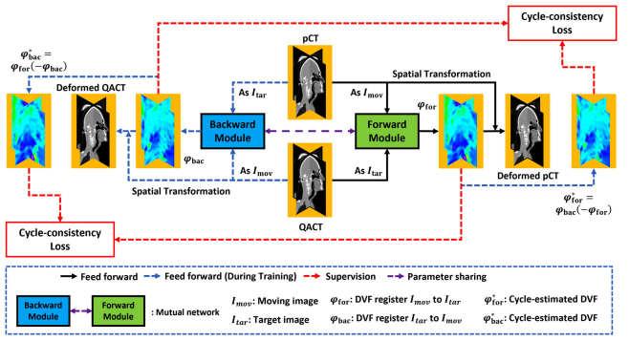

Figure 1: Workflow of the proposed model by Yang Lei et al [1].

Question 3

How did the authors evaluate the quality of the image registration? Compare this to guidelines suggested in the AAPM TG-132 report.

To validate the results, the proposed model was compared with VoxelMorph. In order to evaluate the quality of the image registration qualitative and quantitative evaluations where performed by the authors.

The authors used visual inspections of the deformed, fusion, difference images and intensity profiles to evaluate the image registration quality [1]. The qualitative evaluations of the registration are in compliance with the methods presented in the AAPM TG-132 report [2].

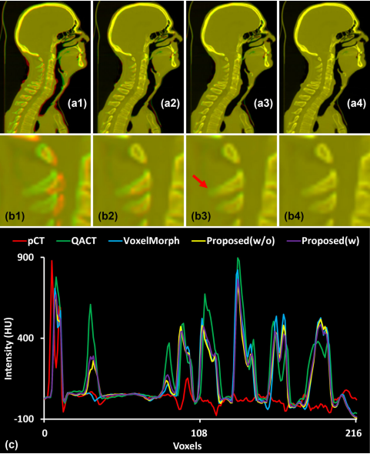

Figure 2: Qualitative evaluation of the image registration from Yang Lei et al. [1]. (a1 & b1) Fusion of patient CT and QA CT. (a2 & b2) Fusion of patient CT and deformed CT using VoxelMorph. (a3 & b3) Fusion of patient CT and deformed CT using model without deformation vector fields. (a4 & b4) Fusion of patient CT and deformed CT using model with deformation vector fields. (c) Intensity profiles of patient CT (pCT), QA CT, deformed CT by VoxelMorph, and deformed CT using proposed methods (with and without deformation vector fields).

Multiple metrics where used for a quantitative evaluation. This metrics are calculated using the patient’s CT and the QA CT (before and after transformation). This metrics are described in Table 1.

|  |  |
| --- | --- |
| Mean Absolute Error (MAE) |  |
| Peak-Signal-to-Noise Ratio (PSNR) | $$PSNR=10*\log_{10}\left(\frac{R^{2}}{MSE}\right)$$ PSNR is the ratio between the maximum signal in the image (R) and the mean squared error (MSE). PSNR is calculated in decibels (dB) [3]. |
| Structural Similarity Index (SSIM) | Measures the similarity between two images considering luminance, contrast and structure [4]. |
| Target Registration Error (TRE) | Calculated as the Euclidian distance between a landmark position in QA CT and the patient’s CT [1,2]. In this work 10 to 20 landmarks where defined per patient [1]. |
| Jacobian determinant of predicted DVF | Determines the changes in volume due to registration [2]. Used for assessment of the DVF (deformation vector fields) [1]. |

Table 1: Metrics used for quantitative evaluation.

The quantitative measurements of image registration align with those proposed by the AAPM TG-132 report [2]. TRE and the Jacobian determinant are used in this work to measure registration accuracy in addition to multiple metrics not specified in the AAPM TG-132.

Question 4

Was there a recommendation from the authors regarding the clinical/research application of image registration? If so, what was their recommendation? If not, what are the proposed next step/s?

Due to the lack of any image preprocessing on the QA CT images, the registration model accuracy is greatly impacted by the image’s quality and is susceptible to artifacts. The authors suggest the further use of deep learning models to improve the image quality. Furthermore, the authors suggest the analysis of the contour propagation, dose volume histogram and dose accumulation in order to evaluate the clinical application of the proposed model [1].

Question 5

Describe the strengths and weaknesses of the study and suggest potential improvements to the methodology/analysis.

|  |  |
| --- | --- |
| Strengths | Weaknesses |
| Fast deformable registration between CTs (<1 minute). | Given a lack of preprocessing on the QA CTs the model accuracy is susceptible to artifacts. |
| Presents a better performance when compared with VoxelMorph. | The model was only trained and tested on head and neck patient patients. Further testing on other structures is required. |
| The use of a mutual network (forward and backward module) enables deformation vector field regularization and topology preservation. |  |
| The neural networked used for this model uses residual blocks, which avoid the deformation of bone structures. |  |

Since the model was trained on head and neck patients training with data sets of different anatomical structures should be used to study the generalization of the model. Furthermore, the use of automatic image preprocessing (deep learning models) should be explored to evaluate the change of image registration quality. Lastly, as stated by the authors, evaluation of the clinical use of the model is required.

References:

1. Lei Y, Fu Y, Tian Z, et al. Deformable CT image registration via a dual feasible neural network. Med. Phys. 2022; 1- 10. https://doi.org/10.1002/mp.15875
2. KK Brock, S Mutic, TR McNutt, et al. Use of image registration and fusion algorithms and techniques in radiotherapy: Report of the AAPM Radiation Therapy Committee Task Group No. 132: Report
3. Mathworks.com. (2020). PSNR: Compute peak signal-to-noise ratio between images. Available at: <https://www.mathworks.com/help/vision/ref/psnr.html>.
4. Zhou Wang, A. C. Bovik, H. R. Sheikh and E. P. Simoncelli, "Image quality assessment: from error visibility to structural similarity," in IEEE Transactions on Image Processing, vol. 13, no. 4, pp. 600-612, April 2004, doi: 10.1109/TIP.2003.819861.

**Task 2**

Question 1

What is the clinical/research application, and why is image segmentation required?

In order to assist with medical diagnosis automatic image segmentation is used to obtain accurate and reproducible results. The work of Ji et al. [1] proposes an automatic segmentation method to increase the performance within small clinical targets.

Question 2

Describe the segmentation algorithm used and provide details of the parameters as appropriate.

The authors propose the use deep learning method with a multi-network architecture (ADR-Net) made of an encoder and decoder divided in 4 down sampling and 4 up sampling operations. The network implements the use of a dense atrous convolution (DAC) block to preserve the information of small size structures, which is otherwise lost during down and up sampling. Also implements an attention gate (AG) mechanism to preserve information and spatial correlation between the encoder and decoder.

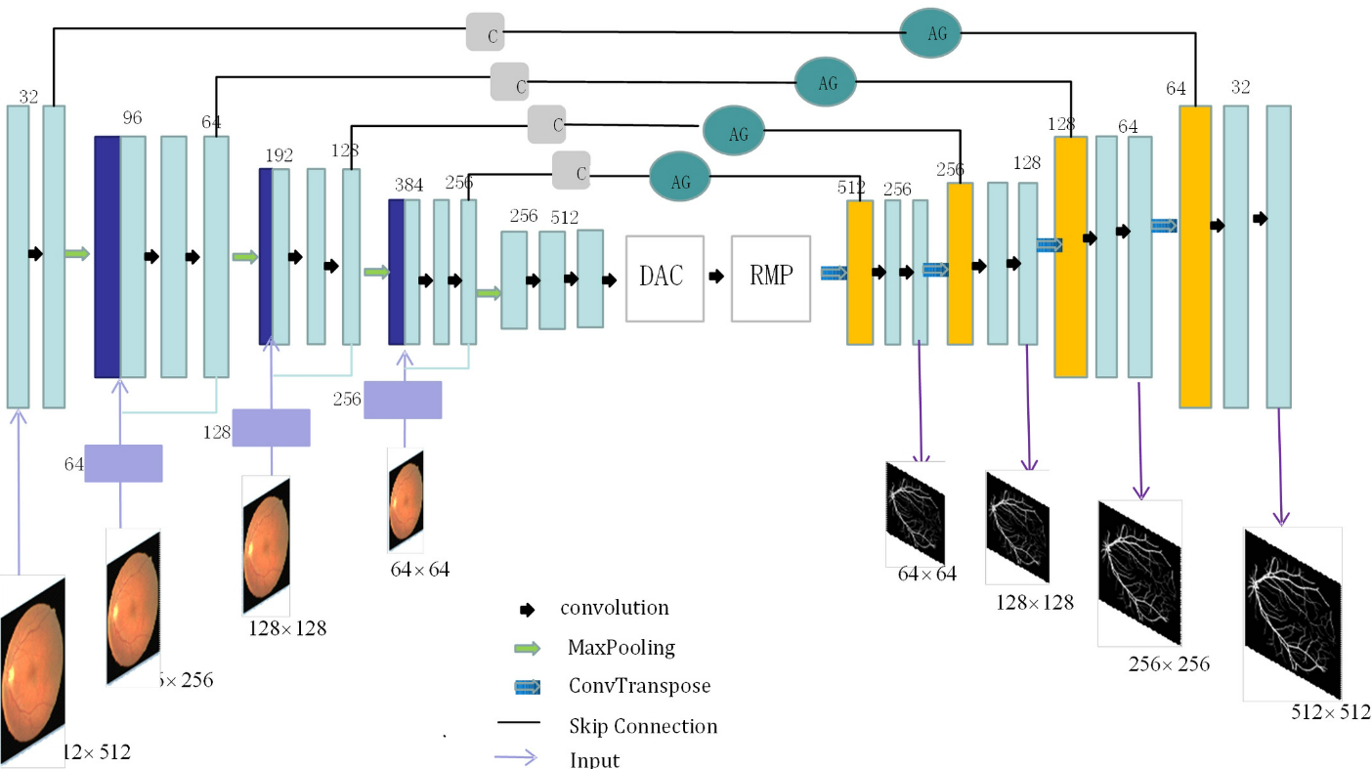

Figure 1: Network architecture proposed by Ji et al. [1].

Question 3

How did the authors evaluate the quality of the image segmentation, and was this compared to other published results?

The authors evaluated the proposed method by performing studies on five different datasets. The performance of this method was comparted to several methods including M-Net and U-Net [1] base methods. For each data set the specificity, sensitivity, accuracy, intersection-over-union, and area under the receiver operating characteristic curve where calculated to compare the results between the different methods.

Question 4

Was there a recommendation from the authors regarding the clinical/research application of image segmentation? If so, what was their recommendation? If not, what are the proposed next step/s?

The authors acknowledged the use of a small dataset and recommend the use of bigger datasets to obtain better training results. Furthermore, the authors suggest preprocessing of the training datasets to improve the overall performance of the network in future studies.

Question 5

Describe the strengths and weaknesses of the study and suggest potential improvements to the methodology/analysis.

|  |  |
| --- | --- |
| Strengths | Weaknesses |
| The implementation of a DAC (dense atrous convolution) block minimizes the loss of boundary information during segmentation. | The network was trained using a limited dataset. |
| Implementation of the AG (attention gate) block improves the accuracy of segmentation of small structures. | When compared to other published methods, the proposed method presents a decrease in accuracy and sensitivity on segmentation of large structures. |
| The proposed method presents a higher segmentation accuracy of small structures when compared to other methods. | The method only provides a binary classification of the structures; thus, it is not ideal for multiple segmentation (i.e. brain tumors). |

The proposed method presents an increase in small target segmentation; nonetheless, it also presents a decrease in large target segmentation. This could be due to the use of a small dataset or lack off data preprocessing. The use of deep learning models for preprocessing is advice for future network training. Additionally the use of a bigger data sets and implementation of multimodality registration is recommended to increase the segmentation quality on lung and brain studies.

References:

1. Ji, L., Jiang, X., Gao, Y., Fang, Z., Cai, Q. and Wei, Z. (2020), ADR-Net: Context extraction network based on M-Net for medical image segmentation. Med. Phys., 47: 4254-4264. <https://doi.org/10.1002/mp.14364>